FIELD
FROM THE
Philippines – Jini Tarampi

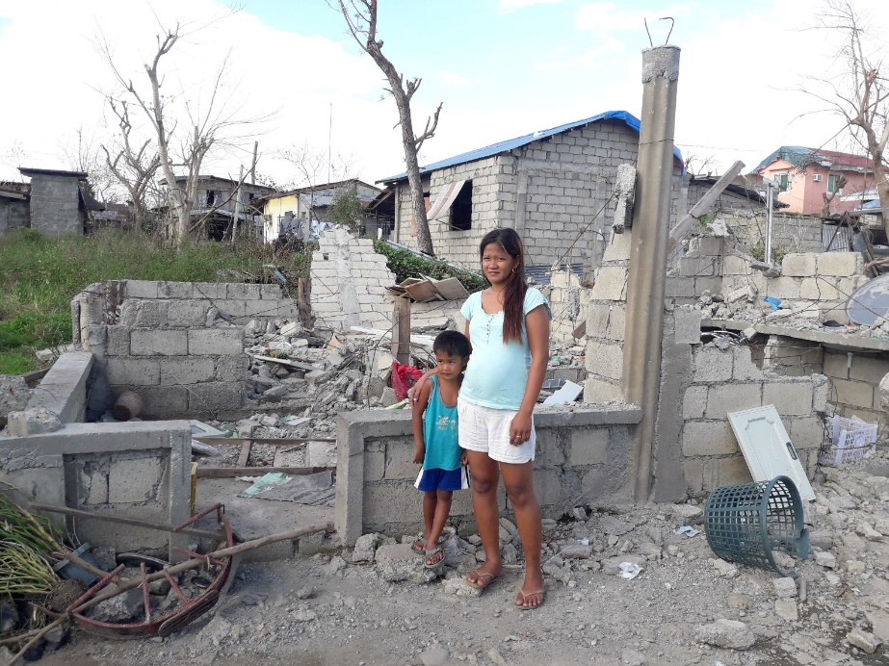
Pregnant mother of three, Jini Tarampi, stands with one of her children on top of the ruins of what once was her home. Her house in the northern province of Cagayan, Philippines was destroyed by super Typhoon Mangkhut (known locally as Typhoon Ompong) in September of 2018.

Jini told the ShelterBox Response Team she earns a living by selling vegetables in the local market, her husband is a taxi driver.

The typhoon hit in the middle of the night. At first, the family were sheltering in their home, but fearing for their lives, they fled to a relative’s house nearby. When they returned in the morning, the family home was completely destroyed. They are now living with Jini’s mother as they so not have the means to rebuild. She tells the team they do not know how they will be able to rebuild their home and are looking for support wherever they can find it.

Learn more about ShelterBox at www.shelterbox.org

