FIELD
FROM THE

Philippines – District 3680

ShelterBox and Rotary respond to disaster in District 3860 Philippines.

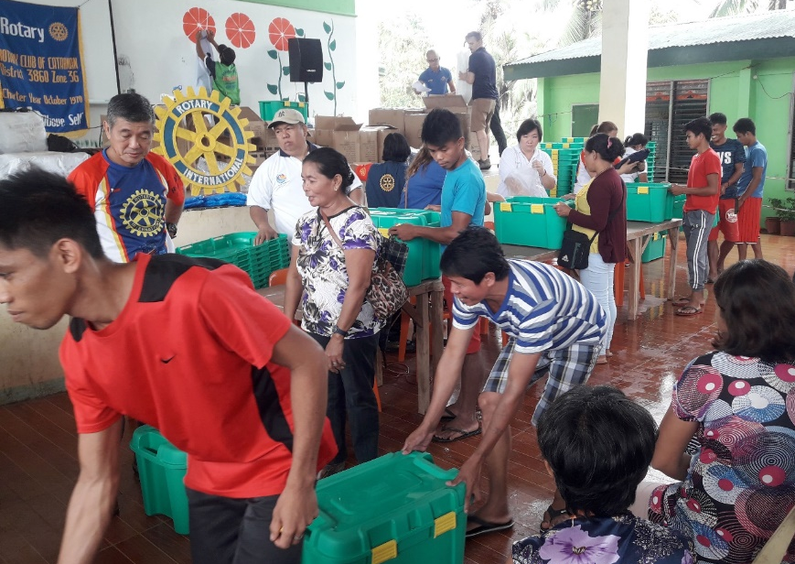
January 2019 - On the island of Samar in the eastern Visayas, north of Tacloban Tropical Depression Usman made landfall 3 days before New Year’s. The storm coincided with northeast monsoon rains resulting in heavy rains which triggered flooding and landslides across the Bicol region, eastern Visayas and Dinagat.
Thankfully, ShelterBox has a registered office and operations team in the Philippines who can quickly respond with trained personnel to assess communities and find families who desperately need shelter, tools and other materials to replace or repair their homes.
ShelterBox response teams work with Rotarians in several aspects of the deployment including distribution, transportation, community liaisons and more. Together, we have supported 2,000 families thus far with a few distributions remaining.

For more information on where we are responding and how you can help visit us at:
WWW.SHELTERBOX.ORG

