FROM THE
Modu Gambo - Nigeria
FIELD

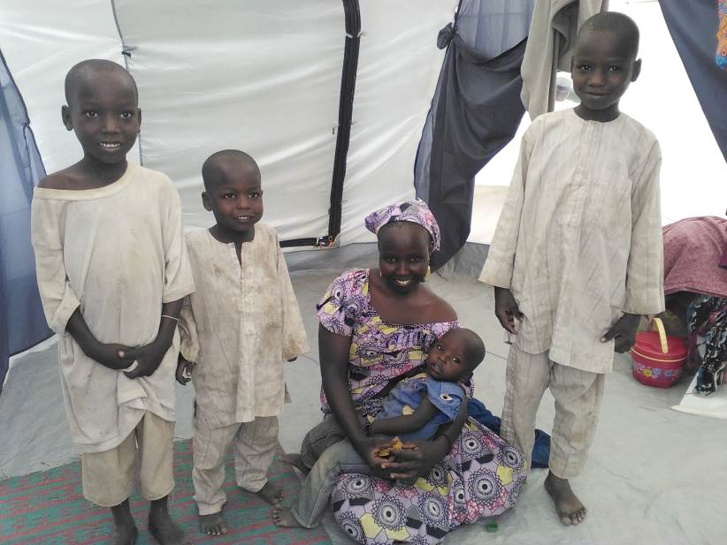
Modu Gambo is originally from Nigeria. She now lives with her four children in Minawao Refugee Camp, Cameroon, home to over 60,000 refugees who fled Boko Haram violence.
In her home village, Modu worked as a trader, and lived with her husband and four children. She told staff at IEDA Relief – ShelterBox’s implementing partner based in Cameroon – they were a united and happy family until the attacks began.
‘It was the beginning of darkness for us’, she said. ‘We had to run to save our lives.’
She said her whole village had been destroyed by Boko Haram, and all her neighbours had fled. After she ran with her children, she never saw her husband again and now cares for her children on her own. She said that she lives in the hope that she will one day see him again.
Weeks after fleeing their home, Modu and her children eventually made it to Minawao camp. She said their first days inside the transit centre at the camp were not easy. Modu found it difficult to sleep at night, she said it was over crowded and they lived in an extremely narrow space.
The family were in the transit centre for a few days before they were relocated to a ShelterBox tent. ‘Since then, life has become so much better. I miss my husband, but I feel highly relieved. We finally have some privacy in our own home’, said Modu. She has made some new friends in the camp who are also refugees and have been through the same as experience as her. She explained that the tent gives them a space to talk in private, something she used to have in the past.
The family received a kitchen set, mosquito nets, solar lights, water carriers and water filters, blankets, and ground mats. Modu was extremely grateful for the aid they received. ‘Thank you so much IEDA and ShelterBox. This tent and the other items we have been given have made my life so much better. I can sleep at night and stay with my family peacefully.’

Learn how ShelterBox is building peace, one family at a time. www.shelterbox.org/peace

