FROM THE
Lombok, Indonesia
FIELD

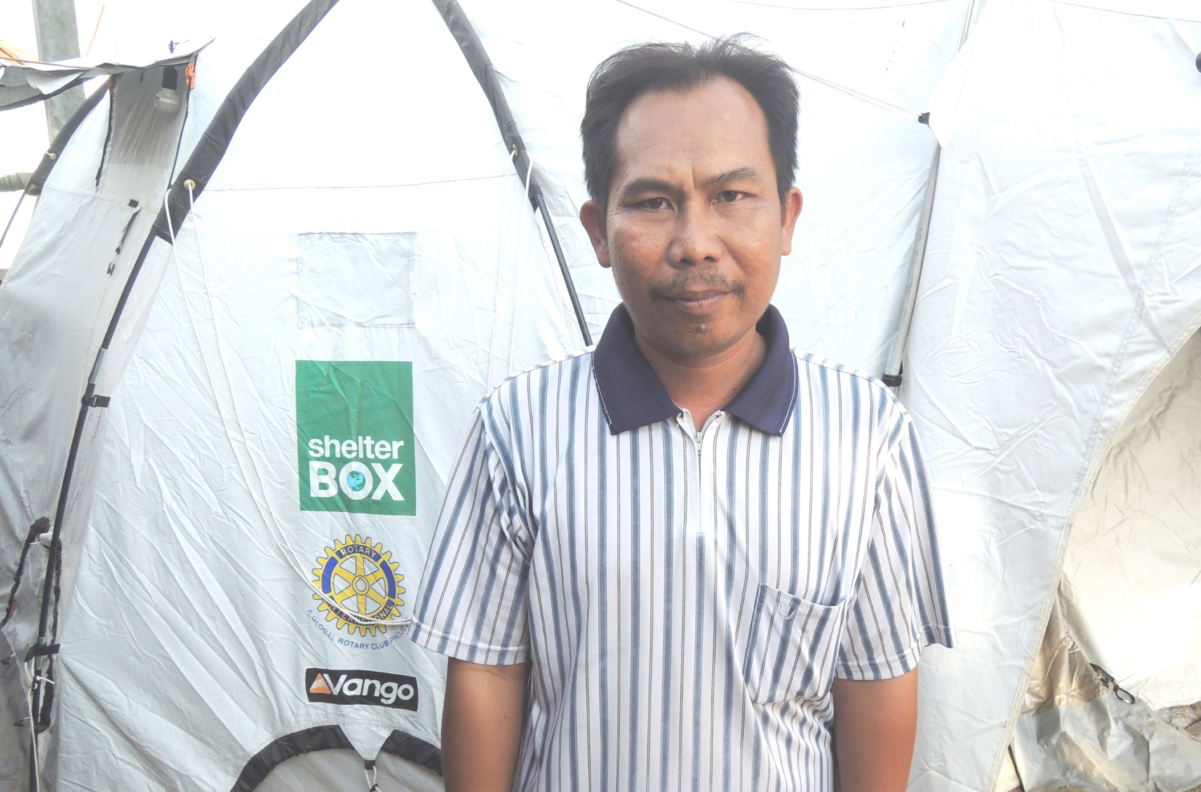
After his wife was killed in the 5th August 2018 earthquake, 40-year-old Ahmad Jaodani was left to look after his four children on his own. We met Ahmad in September the same year, he was living in a ShelterBox family relief tent with his children in Gondang, on the western side of Lombok.

Before the quake hit, Ahmad ran a Launderette business that supported him and his family. His property was totally destroyed which resulted in the loss of the washing machines he used for his business. The family had nowhere to live after the earthquake. They used a small camping tent as their home until ShelterBox and Rotary International were able to provide a much larger family tent for them to live in. There is now a total of nine people, including seven children living together, Ahmad’s immediate and extended family. He says he is happy that they are still with him.

Ahmad told us that he also received blankets, mosquito nets, and other aid items with the tent. He said that these items have all been invaluable in helping the family to meet their basic needs.

Ahmad said that he was very grateful that the help he received means he and his family now feel safe and protected again.

To learn more about ShelterBox and the life saving aid that families receive visit us at:
WWW.SHELTERBOX.ORG

